Quy Pham
ECE 201 LAB
LAB 8
AM and FM Sinusoidal Signal
(Cont.)

4.4.1 Generating the Bell Envelope
function yy = bellenv(tau, dur, fsamp)
%BELLENV produces envelope function for bell sounds
%
%usage: yy = bellenv*tau, dur, fsamp);
%
%where:
%tau = time constant
%dur = duration of the envelope
%fsamp = sampling frequency
%returns:
%yy = decaying exponential envelope
%
%note: produces exponential decay for positive tau
tt = 0:(1/fsamp):dur;
yy = exp(-tt./tau);

4.4.2 The Bell
function xx = bell(ff, Io, tau, dur, fsamp)
%BELL produce a bell sound
%
%usage: xx = bell (ff, Io, tau, dur, fsamp)
%
%where: ff = frequency vector (containing fc and fm)
% Io = scale factor for modulation index
% tau = decay parameter for A(t)and I(t))
% dur = duration (in sec.) of the output signal
% fsamp = sampling rate

%fc = 110; % fc and fm raio 1:2 to create bell sound
%fm = 220;
fc = ff(1);
fm = ff(2);
tt = 0:(1/fsamp):dur;
phi_c = -pi/2;
phi_m = -pi/2;
At = bellenv(tau, dur, fsamp);
It = Io*bellenv(tau, dur, fsamp);
xx = At.*cos(2*pi*fc*tt + It.*cos(2*pi*fm*tt + phi_m) + phi_c);

4.4.3 The Bell Sound
1.
xx1=bell([110,220],10,2,6,11025);
sound(xx1);
xx2=bell([220,440],5,2,6,11025);
sound(xx2);
xx3=bell([110,220],10,12,3,11025);
sound(xx3);
xx4=bell([110,220],10,0.3,3,11025);
sound(xx4);
xx5=bell([250,350],5,2,5,11025);
sound(xx5);
xx6=bell([250,350],3,1,5,11025);
sound(xx6);
2.
The fundamental frequency is the greatest common divisor of the two frequencies.(Carrier frequency and Modular frequency)
X1=gcd(110,220)=110
X2=gcd(220,440)=220
X3=gcd(110,220)=110
X4=gcd(110,220)=110
X5=gcd(250,350)=50
X6=gcd(250,350)=50
3.
The frequencies decrease with increasing time.
function [tt,fi_t] = fiot(ff, Io, tau, dur, fsamp)
%
% usage:
% 3. Ploting fi(t)
%
%where: ff = frequency vector (containing fc and fm)
% Io = scale factor for modulation index
% tau = decay parameter for A(t)and I(t))
% dur = duration (in sec.) of the output signal
% fsamp = sampling rate
%
% return:
% tt = time vector
% fi(t)
%
fc = ff(1);
fm = ff(2);
tt = 0:(1/fsamp):dur;
phi_m = -pi/2;
It = Io*bellenv(tau, dur, fsamp);
fi_t = fc - It*fm.*sin(2*pi*fm*tt) + 1/(2*pi)*(-Io/tau)*exp(-tt/tau).*cos(2*pi*fm*tt);

Plotting:
fsamp = 11025;
[tt1,fi1] = fiot([110,220],10,2,6,fsamp);
[tt2,fi2] = fiot([220,440],5,2,6,fsamp);
[tt3,fi3] = fiot([110,220],10,12,3,fsamp);
[tt4,fi4] = fiot([110,220],10,0.3,3,fsamp);
[tt5,fi5] = fiot([250,350],5,2,5,fsamp);
[tt6,fi6] = fiot([250,350],3,1,5,fsamp);
subplot(3,3,1);
plot(tt1,fi1);
xlabel('Time');
ylabel('fi(t)');
title('fi(t) case 1');
subplot(3,3,2);
plot(tt2,fi2);
xlabel('Time');
ylabel('fi(t)');
title('fi(t) case 2');
subplot(3,3,3);
plot(tt3,fi3);
xlabel('Time');
ylabel('fi(t)');
title('fi(t) case 3');
subplot(3,3,4);
plot(tt4,fi4);
xlabel('Time');
ylabel('fi(t)');
title('fi(t) case 4');
subplot(3,3,5);
plot(tt5,fi5);
xlabel('Time');
ylabel('fi(t)');
title('fi(t) case 5');
subplot(3,3,6);
plot(tt6,fi6);
xlabel('Time');
ylabel('fi(t)');
title('fi(t) case 6');
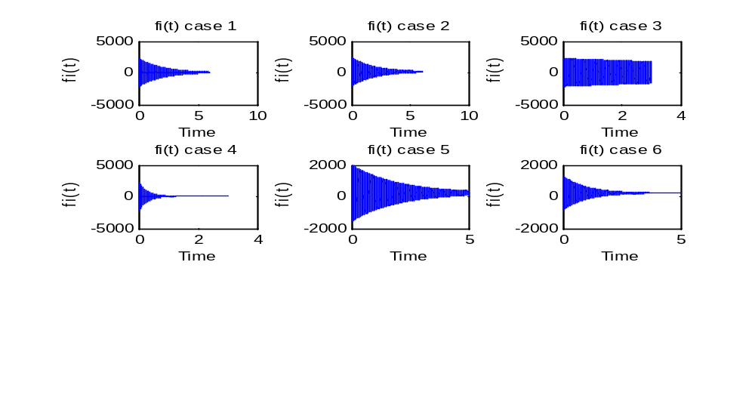
4.
xx2=bell([220,440],5,2,6,11025);
tt2=0:1/11025:6;
xx6=bell([250,350],3,1,5,11025);
tt6=0:1/11025:5;
subplot(2,2,1);
plot(tt2,xx2);
xlabel('t');
ylabel('x(t)');
title('case 2');
subplot(2,2,2);
specgram(xx2, [], 11025);
subplot(2,2,3);
plot(tt6,xx6);
xlabel('t');
ylabel('x(t)');
title('case 6');
subplot(2,2,4);
specgram(xx6, [], 11025);
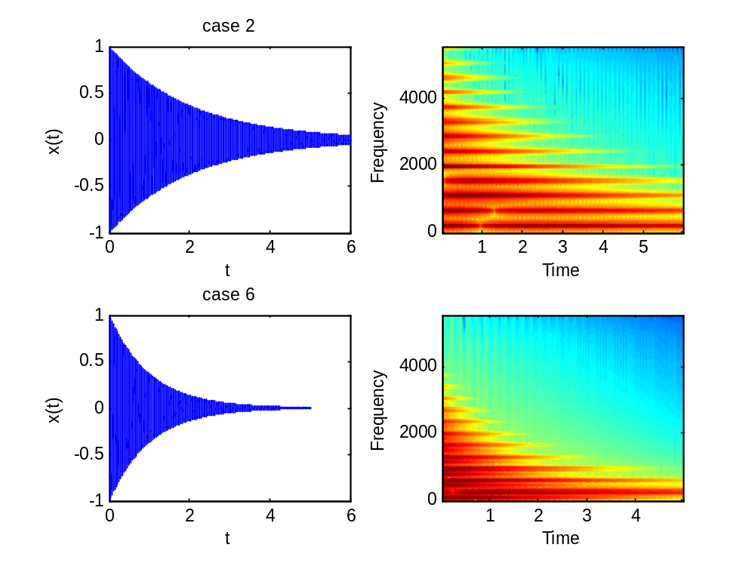
5.
fsamp = 11025;
xx1 = bell([110,220],10,2,6,11025);
tt1 = 0:(1/fsamp):6;
At1 = bellenv(2,6,fsamp);
xx6 = bell([250,350],3,1,5,11025);
tt6 = 0:(1/fsamp):5;
At6 = bellenv(1,5,fsamp);
subplot(2,2,1);
plot(tt1,xx1);
xlabel('t');
ylabel('x(t)');
title('case 1');
subplot(2,2,2);
plot(tt1,At1);
xlabel('t');
ylabel('A(t)');
title('case 1');
subplot(2,2,3);
plot(tt6,xx6);
xlabel('t');
ylabel('x(t)');
title('case 6');
subplot(2,2,4);
plot(tt6,At6);
xlabel('t');
ylabel('A(t)');
title('case 6');
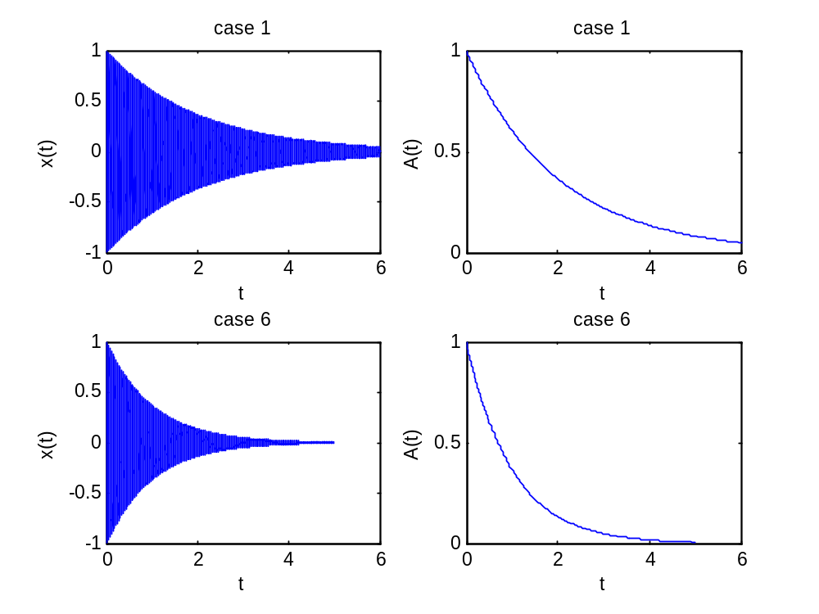
The signals and the envelope A(t) generated by bellenv() look similar to each others.
6.
fsamp = 11025;
xx3 = bell([110,220],10,12,3,fsamp);
xx4 = bell([110,220],10,0.3,3,fsamp);
tt3 = 0:1/fsamp:3;
tt4 = 0:1/fsamp:3;
figure(1);
plot(tt3,xx3);
axis([1.5 1.51 -1 1]);
xlabel('t');
ylabel('x(t)');
title('case 3');
figure(2);
plot(tt4,xx4);
axis([1.49 1.51 -0.01 0.01]);
xlabel('t');
ylabel('x(t)');
title('case 4');
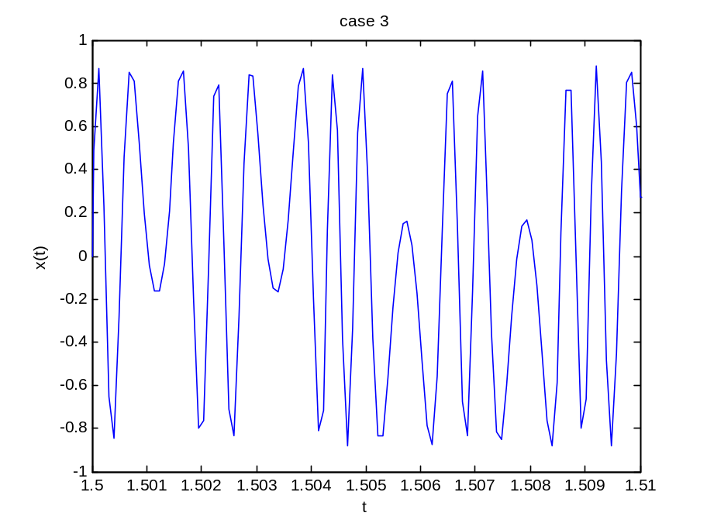
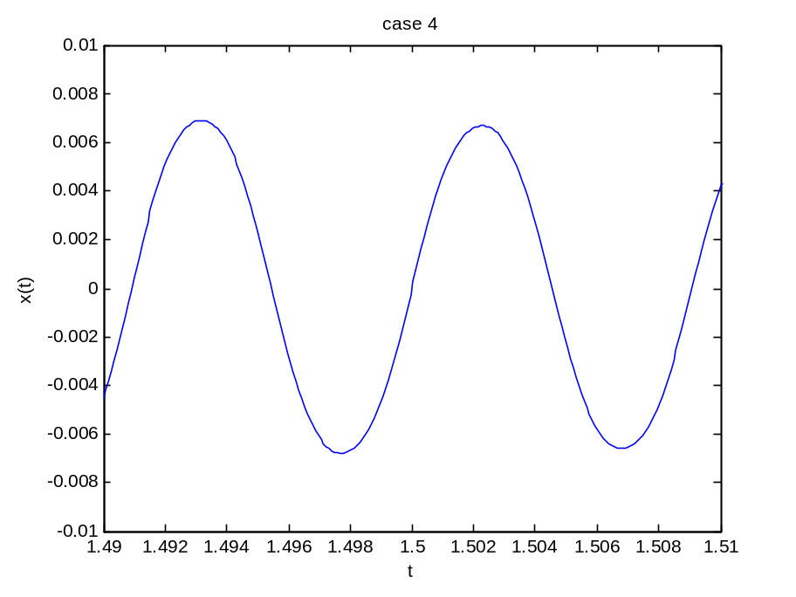

By comparing these 2 signals, it shows that the smaller the time constant is (tau) the smoother and beautiful the signal is.

